
PHYS 121 Labs
The Speed of Sound

Introduction
Sound is a part of everyday life—whether it's the honk of a car horn, the strum of a guitar, or the ringing of a bell. Scientifically, sound is a mechanical wave that propagates through a medium such as air, water, or solid materials. But how fast does sound travel in these media? Does its speed remain constant, and what factors affect it?
In this lab, you will explore the nature of sound waves and investigate how their speed is influenced by the properties of the medium. Through hands-on experiments using ultrasonic transducers and oscilloscope-based measurements, you will determine the speed of sound in both air and water.
Goals
• Understand the relationship between sound speed and thermodynamic properties of gases.
• Learn the principles of ultrasound generation and detection using piezoelectric transducers.
• Measure the speed of sound in air and water using the traveling wave and standing wave methods.

Theory
Sound is a mechanical, longitudinal wave generated by the vibration of matter. Unlike electromagnetic waves, sound requires a medium (solid, liquid, or gas) to propagate. It travels by compressing and rarefying particles within the medium. In a vacuum, sound cannot propagate due to the absence of particles. Humans can hear frequencies between 20 Hz and 20 kHz, while sounds above this range are referred to as ultrasound.
- Sound propagation in air
The speed of sound $v$ in an ideal gas is
 | $$v=\sqrt{\frac{γRT}{M}}$$ | (1)
where $γ={C_{P}}/{C_{V}}$ is the ratio of specific heats for a gas at a constant pressure ($C_{P}$) to a constant volume ($C_{V}$), $R$ (approximately 8.314 5 J·mol⁻¹·K⁻¹) is the molar gas constant, $T$ is the absolute temperature, and $M$ is the molar mass of the gas. The ratio $γ$ = 5/3 for an ideal monoatomic gas and $γ$ = 7/5 for air, which is predominantly a diatomic gas (the major constituents of Earth atmosphere are nitrogen and oxygen). The mean molar mass for dry air (0% humidity) is about 28.966 x 10⁻³ kg/mol.
The approximate speed of sound in dry air, at temperatures near 0 °C (or 273.15K) and atmospheric pressure ($p=101.3$ kPa) is 331.5 m/s. With the following formula you can calculate exactly the speed of sound in m/s
 | $$v=331.5\sqrt{1+ \frac{t}{273.15}}$$ | (2)
where $t$ is temperature in degrees Celsius. In reality, there is always water vapor in air. Upon applying correction to $M$ and $γ$, the speed of sound (m/s) is given as
 | $$v=331.5\sqrt{\left(1+ \frac{t}{273.15}\right)}\left(1+0.16\frac{rp_{s}}{p}\right)$$ | (3)
where $r$ is relative humidity of air, $p_{s}$ is saturation vapor pressure at $t$ °C.$p_{s}$ can be calculated using the following formula
 | $$\log_{10}{p_{s}}=10.286-\frac{1780}{237.3+t}$$ | (4)
- Sound propagation in water
In pure water, the speed of sound $v$ is
 | $$v=\sqrt{\frac{K}{ρ}}$$ | (5)
where $K$ is bulk modulus of water and $ρ$ is density of water. The bulk modulus (Pa or N/m²) and density of water can be calculated using empirical formulas
 | $$K=-1.2348×{10}^{5}t^{2}+{1.3659×10}^{7}t+1.9692×{10}^{9}$$ | (6)

 | $$ρ={-5.1636×10}^{-3}t^{2}+{7.3115×10}^{-3}t+1.0001×{10}^{3}$$ | (7)
where t is temperature with a range of 4 - 40 ͦC.
- Experimental methods to determine speed of sound
The speed of sound can be calculated using Equation 8 below. According to this formula, if the frequency ($f$) and wavelength ($λ$) of a wave are known, the speed ($v$) can easily be calculated by multiplying the two values together.
 | $$v=fλ$$ | (8)
The frequency ($f$) of a sound wave is determined by the signal generator used to produce the sound. The wavelength of a sound wave can be determined using two methods:
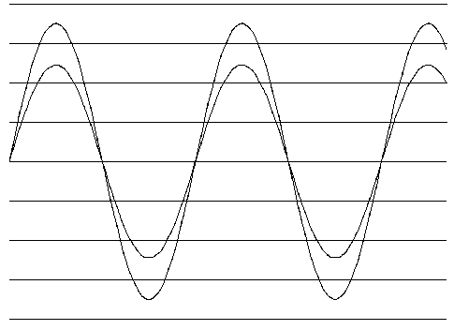
3.1 Traveling wave method
Figure 1 Transmitter and receiver IN PHASE
The sound waves are radiated when a transducer is fed an alternating current of the appropriate frequency from an electrical oscillator (transmitter, ‘the reference’). In turn, these waves induce electrical signals in the other transducer (receiver). When the transmitter and receiver are connected to a dual channel oscilloscope, the corresponding sine waves can be viewed on the oscilloscope. Two waves that are “in phase” (phase difference of 0 radians) have their peaks at the same position at the same time (Fig. 1). By observing how far the receiver must be moved to cause its graph to change between in phase with the transmitter’s graph, we can measure the wavelength of the sound wave. The wavelength $λ$ of a traveling sinusoidal wave is defined as the distance between two points in the medium for which there is a phase difference of 2π. Suppose the receiver is first placed at a point where the oscilloscope screen shows a pattern like Fig. 1. As the receiver is moved along the path, a second point will be found where the same pattern appears as it did originally. The phase of the wave has, therefore, increased by 2π between the first and second points and the distance is one wavelength $λ$.
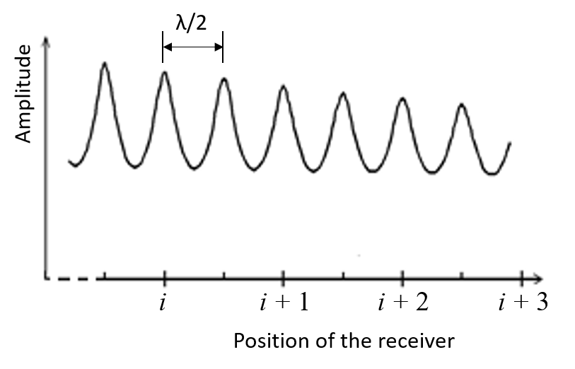
3.2 Standing wave method
Figure 2 Standing wave
As a sound wave propagates down to the receiver, it is reflected and returns to the transmitter. When the incoming and reflected waves encounter each other in the same medium, they combine under certain conditions to yield standing waves. Standing waves are patterns whose points of maximum and minimum (zero) amplitude are fixed so that, apart from a rapid vibration of the medium, the pattern appears to be standing still (vibrates between the adjacent minimums). At certain frequencies of oscillation, the reflected waves are in phase with the incoming waves, resulting in a standing wave with a large amplitude. These frequencies are called resonant frequencies. As the receiver is moved along the path, the largest amplitude of its wave changes periodically. As shown in Fig. 2, the distance between two adjacent maxima corresponds to half of the wavelength $λ/2$.
Note: Both standing wave and traveling wave patterns occur during the propagation of sound.
Experimental set-up
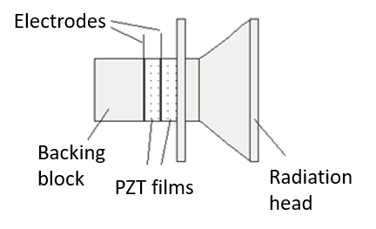
Ultrasound and piezoelectric transducer
Figure 3 PZT transducer
Ultrasound waves can be generated by material with a piezoelectric effect. The piezoelectric effect is a phenomenon exhibited by the generation of an electric charge in response to a mechanical force (squeeze or stretch) applied on certain materials. Conversely, mechanical deformation can be produced when an electric field is applied to such material, also known as the inverse piezoelectric effect. Both natural and human-made materials, including quartz crystals and ceramic materials, can demonstrate piezoelectric properties. PZT, or lead zirconate titanate, is one of the world’s most widely used piezoelectric ceramic materials. It is used to make transmitting transducer and receiving transducer for measuring the speed of sound in this lab (Fig. 3).
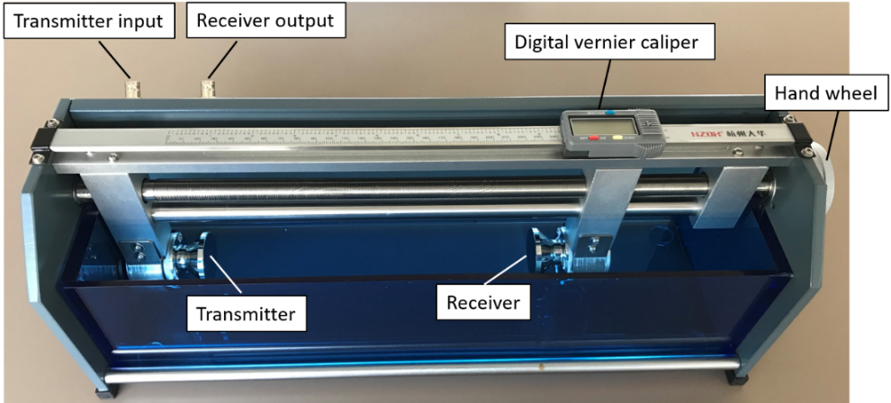
The experimental set-up consists of a sound velocimeter, a function generator and an oscilloscope.
Figure 4 Sound velocimeter

Sound velocimeter
As shown in Fig. 4, the sound velocimeter contains i) a transmitter; ii) a receiver; and iii) a receiver location adjustment unit. The receiver can be moved along a rod by rotating a hand wheel. The location of the receiver can be determined with a digital vernier caliper. The caliper has a resolution of 0.01 mm and a reading error of 0.01 mm.
Function generator
A function generator produces repetitive waveforms such as sine waves, square waves and triangular waves. Read the manual before measurement.
Oscilloscope
An oscilloscope graphically displays varying signal voltages, usually as a two-dimensional plot of one or more signals as a function of time. Read the manual before measurement.

Procedure
Your partner and you will choose to explore the speed of sound in air/water. Student who chooses to explore speed of sound in air will need to complete Tables 1 and 3. Student who chooses to explore speed of sound in water will need to complete Tables 2 and 3.

1. Theoretical calculation for the speed of sound in air/water
Record the temperature and humidity values before and after the experiment and take the average values for calculation.
Fill out Table 1 or 2 as requested.

Table 1 Theoretical calculation for the speed of sound in air
 |  | Note
t (ͦC) |  | to measure (resolution 0.1 ͦC)
r (%) |  | to measure (resolution 1%)
p (Pa) | 1.024 x 10⁵
p_{s} (Pa) |  | Equation 4 (after lab)
$v$ (m/s) |  | Equation 3 (after lab)

Table 2 Theoretical calculation for the speed of sound in water
 |  | Note
t (ͦC) |  | to measure (resolution 0.1 ͦC)
K (N/m²) |  | Equation 6 (after lab)
$ρ$ (kg/m³) |  | Equation 7 (after lab)
$v$ (m/s) |  | Equation 5 (after lab)

2．Experimental methods to determine speed of sound
The transmitter of the sound velocimeter is connected to CH1 of the function generator and CH1 of the oscilloscope via BNC cables. The receiver of the sound velocimeter is connected to CH2 of the oscilloscope.
Read the user manuals for the function generator and oscilloscope before performing the measurement.
Note: Keep the receiver at least 50mm away from the transmitter.

2.1 Traveling wave method for measuring speed of sound in air
a). Move the receiver around 50 mm away from the transmitter. Switch on the function generator and oscilloscope. Set the function generator to get a sine wave of 5 Vpp (peak-to-peak value) with a frequency of 40 kHz. Set both offset and phase as 0. Press Output1 on the generator. Press AUTO on the oscilloscope. The two received signals are displayed as curves of voltage vs. time on oscilloscope. Observe what happens to the scope display when you slightly vary the frequency from the generator. Adjust frequency $f$ until the oscilloscope shows maximum amplitude on the receiver. Record the frequency $f$ in Table 3. Keep using the same parameters including frequency $f$, amplitude, offset and phase for the rest of measurement.
b). Move the receiver along the path and record the corresponding positions where the transmitter and receiver waves are in phase. Fill in Table 3 with your data.

  - Standing wave method for measuring speed of sound in water
a). Carefully assemble the water tank with the sound velocimeter. Make sure the transmitter and receiver are fully immersed in water.
b). Repeat 2.1 step a. Instead of 40 kHz, set the initial frequency to 70 kHz to find frequency $f$ and record it in Table 3.
c). Slowly move the receiver along the path and record the corresponding positions where the amplitude of receiver’s wave reaches maximum (as shown in Fig. 2). Fill in Table 3 with your data.

Table 3. Experimental methods to determine speed of sound (no less than 6 sets?)
Speed of sound in AIR (Traveling wave method)
Speed of sound in WATER (Standing wave method)
$f$= ______________ (kHz) (resolution: 0.001kHz)
i (n = 6-20) | l_{i} (mm)
1
2
…
n

Determine the slope $b_{1}$ of the following equation using data from Table 3. Depending on which method you use for the measurement, $b_{1}=λ or λ/2$

 | $$l_{i}=b_{0}+ b_{1}i$$ | (9)
Calculate the speed of sound $v$ using Equation 8.

Error analysis
The uncertainty of frequency is $U_{f}≈0.05\%f$
The uncertainty of wavelength can be calculated using the following formula
 | $$U_{λ}=U_{b_{1}}=ts_{b_{1}}≈\left(1.959+\frac{2.406}{\left(n-2\right)-1.064}\right)s_{b_{1}}$$ | (10)
where $s_{b_{1}}$ is the standard deviation of the slope $b_{1}$ and $n$ is the number of data points.
The combined uncertainty of speed of sound is then given by
 | $$U_{v}=v\sqrt{{\left(\frac{U_{f}}{f}\right)}^{2}+{\left(\frac{U_{λ}}{λ}\right)}^{2}}$$ | (11)
Therefore, $v^{'}=v± U_{v}=________m/s$

Discuss about the values obtained for the speed of sound in air/water using theoretical and experimental calculation.

Lab report
Each person is required to type a lab report and submit the electronic copy to Gradescope in one week after your lab session.
Write your lab report by following the Guidelines for a Physics Lab Report (template and grading rubrics) which has been uploaded to Canvas.

Questions
You should include the answers to the following questions in the lab report.
- How to derive Equation (1) the speed of sound in an ideal gas?
- “Adjust frequency $f$ until the oscilloscope shows maximum amplitude on the receiver.” Why does this happen?

